Mind Of My Own

Press Pack

MOMO Launch 29/10/13, National Care Leavers Week

www.mindofmyown.org.uk

Contents
sixteen25 Launch UK’s First Self-Advocacy App for Children in and Leaving Care in Aid of National Care Leavers Week 2
Press Contacts 3
Notes to Editor 3

Quotes 4
Statistics 6
Urls 7
Case Study 1: Roberto Avoids Homelessness With The Help Of MOMO 8
Case Study 2: Annie Speaks Up And Takes Part In Planning Her Care For The First Time 10
Images, Logos & Screenshots 12

FOR IMMEDIATE RELEASE MONDAY 28 OCTOBER

sixteen25 Launch UK’s First Self-Advocacy App for Children in and Leaving Care in Aid of National Care Leavers Week

Mind Of My Own (MOMO) is a new app for young people in and leaving care, launched in aid of National Care Leavers Week 2013, at the Access All Areas Conference held in central London on Tuesday 29 October 2013.

MOMO is available on smartphones and online for free, and is designed to promote self-advocacy for young people, enabling them to be in control and at forefront of their care. A cross-sector team of advocates, young people and digital designers have created the app, led by young people’s social enterprise sixteen25 and funded through the Nominet Trust Digital Edge Programme. Over a six month design period the team worked alongside 14 young testers in Bexley and Surrey to help produce an app which allows their voices and those of the rest of 91,000 looked after children in the UK to be heard and influence the services they receive.

As advocacy services and social care budgets become increasingly limited, time is reduced and access to services is often difficult. MOMO enables young people to express their views, wishes and feelings to their care team in a structured format, helping increase service effectiveness and give the young user a sense of control over a situation and their wider care plan.

Guided by a series of questions and prompts, young people using the app can prepare for a review, get something changed or build a complaint through a well presented format enabled by the app. The app increases young people’s participation in reviews and improves their engagement with care staff. It makes it easier for hard to reach groups to access advocacy services and helps all services for young people to deliver improved outputs and better outcomes.

MOMO is an ambitious way to improve young people’s involvement and access to services, and their ability to self-advocate. Tuesday’s launch also marks the start of a process towards more accepted and widespread use of digital technology in the social care sector.

Yvonne Anderson, Director, sixteen25, says “With widespread cuts to advocacy and social care budgets it’s never been more important to provide children and young people who are looked after or leaving care with resources they can easily use to engage with services. The MOMO app enables young people to have their say in an accessible, simple and effective way.“

Annika Small, CEO of Nominet Trust, says, ‘It is so important for young people to have a voice in their own care and treatment. MOMO challenges the balance of power between young people and professionals, using digital technology to increase young people’s agency and engagement. Nominet Trust is delighted to support MOMO as an outstanding example of the potential of digital technology to widen access and deepen engagement by traditionally hard-to-reach groups.’

For more information, visit: http://mindofmyown.org.uk

-Ends-

Press Contacts
Joe Roberson, Project Lead
07834 364 205
joe@mindofmyown.org.uk

Annabelle Davis, Project Lead
07506 726 880
annabelle@mindofmyown.org.uk

Full press pack
http://mindofmyown.org.uk/wp-content/uploads/2013/10/Press-Pack-Mind-Of-My-Own-Launch-291013.docx

Notes to Editor

About sixteen25
www.mindofmyown.org.uk
sixteen25 is a Community Interest Company set up in 2010 to develop innovative solutions to meeting the health and social care needs of vulnerable young people. Our aim is to transform their experience of being a young person so they become confident, empowered, and less service dependent, adults.

We want to bridge the gap between current practice in providing support to young people and their increasing use of digital technology to express their views. This involves challenging the balance of power between young people and professionals and revolutionising the way that they are involved in their own care and treatment.

About Nominet Trust
www.nominettrust.org.uk
Nominet Trust is the UK’s leading Tech for Good funder. The Trust believes in harnessing the power of digital technology to improve lives and communities.

A UK registered charity, Nominet Trust brings together, invests in and supports people committed to using digital technology to create social and economic value.

Nominet Trust has invested in hundreds of projects since its inception, providing business support as well as financial investment, seeking to connect projects to prospective partners who can help increase their reach and impact.

Nominet Trust was founded in 2008 by Nominet, the not-for-profit organisation responsible for the smooth and secure running of the .uk internet infrastructure. Nominet has a strong public purpose and the Trust is one example of its commitment to creating a safer, accessible and diverse internet.

Quotes

“This is the way forward…”
Unsolicited quote from Councillor Katie Perrior, Bexley Lead Member
for Looked After Children

“It’s good. So, say its 10pm and you’re lying in bed and you’ve got a problem in your head that you can’t get out because there’s no one to answer a phone. You can just download MOMO onto your phone and do it there and then get it off your chest and send it to everyone involved.”
David, Care Leaver, Bexley

“If I hadn’t used MOMO I think it would have been a lot harder. 2 days after using MOMO I got stuff sorted. Without it I probably wouldn’t have told them. It helped me get to know my social worker better.”
Shannon, Young Person, Bexley

“It’s amazing. It gives young people a voice. It gives them a chance to get things off their mind and get them dealt with – in a way that won’t be forgotten about or become just another note on their case file. In fact they are putting the notes in their case file, notes of exactly what they want and how they want them. It’s so clear. There’s no way an adult couldn’t understand what a young person is trying to say. I think it’s revolutionary.”
Becky Gunner, LAC Project Officer, Bexley

The results have been extremely positive. Much better than I expected. For young people who don’t like to speak or meet face to face it’s a really good way to use something more familiar. It’s a really good way to develop self advocacy.

I think it also promotes the advocacy service itself and it promotes the inclusion of young people who don’t have access to an advocate.
Karen Colverson, Senior Advocate, NYAS

“MOMO is a wonderful simple and practical tool to help looked after children and care leavers to express themselves fully and confidently. We live in an age where we take participation for granted, but many many care leavers still tell us that they don’t feel confident to speak out about things that affect their lives, or they don’t think there is any point because ‘the adults do what they want anyway’. An App like this should not replace good communication but can help break down barriers where vulnerable young people and young adults feel their voice isn’t heard. It is also something that could be used as an aid where there is already good communication. The Care Leavers’ Foundation supports anything that improves communication and we look forward to seeing how this innovative App works in practice”
Janet Rich, Trustee, The Care Leavers’ Foundation [-ENDS-]

Statistics

About Leaving Care
Every year thousands of young people have a negative experience of transitioning into adult services. The process can have devastating repercussions that last throughout adulthood, damaging their ability to participate in building a resilient society.

Since the Social Inclusion Unit’s final report in 2005 we’ve seen little progress anywhere in the UK (Singh et al 2010). There is still a lack of specialist transition services, lack of accessible advocacy services and lack of expertise in engaging with them. Young people’s lack of trust in services and frustration at not being heard further undermines their ability to control their experience.

Statistics
- There are almost 91,000 looked after children in the UK at any one time and around 11,000 young people aged 16 or over leave the care system every year.
- 30% of homeless people have been in the care system. For the majority who do stay housed, there's the challenge of balancing college or work with the need to be completely self-reliant (ref. Case Study 1)
- One third of care leavers are not in education, employment or training - compared with 13% of all young people (ref. Case Study 1)
- In 1991 the UK Government ratified the United Nations Convention on the Rights of the Child (UNCRC). The Convention includes two specific rights related to the voice of the child:
  - Article 12: You have the right to say what you think should happen when adults are making decisions that affect you, and to have your opinions taken into account. (ref. Case Study 2)
  - Article 13: You have the right to get, and to share, information, so long as the information is not damaging to yourself or others.
- Children and young people in care are experiencing inconsistency across England and Wales in getting advocacy help which can have a massive impact on their lives. (The Children’s Society/Children’s Commissioner for Wales) (ref. Case Study 2)
- Advocacy has low costs, 'enormous benefits' and is 'a life-changing tool' (The Children’s Society)
- In Wales many children and young people do not know that advocacy services exist or that they have an entitlement to receive advocacy (Missing Voices)
- 27% of 16 year old care leavers are given council accommodation, benefits and are left to get on with it (ref. Case Study 2)
- General stats on children in care http://www.thewhocarestrust.org.uk/pages/the-statistics.html

Urls
Main site: www.mindofmyown.org.uk (for app download links, app browser version, Service MOMO and MOMO Champions programme).

Developers: www.neontribe.co.uk

Partner Orgs: Surrey (www.surreycc.gov.uk/), VoiceAbility Bexley (www.voiceability.org.uk) and NYAS Bexley (www.nyas.net)

Funders: www.nominettrust.org.uk

National Care Leaver’s Week: http://www.thecareleaversfoundation.org/About_NCL_Week

Access All Areas Conference: http://www.princes-trust.org.uk/about_the_trust/what_we_do/from_care_to_independence/news/1307_access_all_area.aspx

Case Study 1: Roberto Avoids Homelessness With The Help Of MOMO
Short Version
Roberto is a care leaver with mental health issues. When he becomes homeless his only friend helps him use MOMO to explain his situation to his disconnected social worker and leaving care team. When they arrange to meet Roberto he uses MOMO to prepare for it so he can tell them about the other things that he needs help with like having something good to do.

When he receives Roberto’s statement his leaving care worker is able to quickly grasp the seriousness of Roberto’s situation. When they meet he helps him develop a short and long term plan. Roberto feels really listened to and better about keeping in touch with his worker. Within three months he has his own accommodation and is on a college course.

Stats
- There are almost 91,000 looked after children in England at any one time and around 11,000 young people aged 16 or over leave the care system every year.
- 30% of homeless people have been in the care system. For the majority who do stay housed, there's the challenge of balancing college or work with the need to be completely self-reliant.
- One third of care leavers are not in education, employment or training - compared with 13% of all young people

Long Version
Roberto is 18 and a care leaver. He left care when he was 16 and has been struggling to grow into adulthood ever since.

Roberto had mental health problems as a younger teen, diagnosed as Post Traumatic Stress Disorder probably brought on by his abusive early childhood. He experiences night terrors regularly. This is compounded by his asthma that leaves him struggling for breath after waking.

For the last six months he’s been living with his girlfriend in her flat in Wilmslow. Their relationship is difficult. She works but he has no job and isn’t at college. He is fairly chaotic in his life, with few real friends and an unstable relationship with Ray, his leaving care worker who he last saw three months ago.

Roberto’s MOMO Story
Roberto’s journey with MOMO begins when he splits up with his girlfriend. She kicks him out and he spends the next three nights on the streets until he gets a call from his old friend called Fred, a care leaver himself. Fred had heard Roberto was in trouble and offers him his sofa for the night. He comes to meet Roberto who is in a bad way.

Fred wants to help Roberto. Last year Fred’s advocate introduced him to MOMO and he used it to make a formal complaint. Though Roberto doesn’t have a smartphone, Fred does. He shows Roberto how it works and finds out that he has a right to help with finding accommodation. Fred tells him he should use it to contact his social worker and leaving care team.

Guided by MOMO’s prompts and questions, Roberto and Fred spend half an hour putting a statement together. The statement explains Roberto’s situation, affirms his right to support and that he would like help with finding somewhere to live. When they are done MOMO gives them some send and save options. Because Roberto’s social care department have purchased Service MOMO the app gives Roberto the option to send his statement straight to his social worker/leaving care team.

Roberto’s statement arrives with his social worker and leaving care team by email. They send it on to Ray, Roberto’s leaving care worker. Ray is able to clearly see Roberto’s situation and calls him immediately. They arrange to meet the next day.

Before the meeting Fred helps Roberto to prepare by using MOMO’s ‘Prepare for a Meeting’ function. MOMO prompts Roberto to talk about how he’s feeling and the other things in his life that he wants help with. It then formats his words into a smart statement that Roberto can email to Ray from within MOMO. When Ray receives the statement he can immediately see that Roberto needs help with other areas of his life too. This helps Ray to prepare too. By being fore-notified Ray is able to spend more time with Roberto planning how to tackle his problems.

Roberto and Ray meet. Ray is able to show Roberto that he understands his situation and has some ideas for how to help. Roberto feels reassured that Ray has already listened to him and opens up more to Ray’s proposed solutions. He is able to make some small decisions which helps Ray to move more quickly to find him somewhere to live.

Roberto stays with Fred for two more days while Ray sorts out short term hostel accommodation for him. Ray also helps Roberto to apply for his own flat and enrol on a welding course in college. Within three months Roberto has his own place to live and is about to start the course

Case Study 2: Annie Speaks Up And Takes Part In Planning Her Care For The First Time
Short Version
Annie’s lived in 17 placements and hasn’t attended a review meeting for 5 years. She’s about to leave care only she’s finally found a foster placement she feels safe in. She hates speaking up but when she hears about MOMO through her children’s rights pack she uses it to tell everyone how she feels.

When they receive Annie’s statement her advocacy service are able to quickly get involved. They support Annie to express her views at a meeting for the first time in 5 years. Her pathway plan is changed and she is able to stay in her placement for another two years.

Stats
- In 1991 the UK Government ratified the United Nations Convention on the Rights of the Child (UNCRC). The Convention includes two specific rights related to the voice of the child:
  - Article 12: You have the right to say what you think should happen when adults are making decisions that affect you, and to have your opinions taken into account.
  - Article 13: You have the right to get, and to share, information, so long as the information is not damaging to yourself or others.
- Children and young people in care are experiencing inconsistency across England and Wales in getting advocacy help which can have a massive impact on their lives. (The Children’s Society/Children’s Commissioner for Wales)
- Advocacy has low costs, 'enormous benefits' and is 'a life-changing tool' (The Children’s Society)
- In Wales many children and young people do not know that advocacy services exist or that they have an entitlement to receive advocacy (Missing Voices)
- 27% of 16 year old care leavers are given council accommodation, benefits and are left to get on with it
- General stats on children in care http://www.thewhocarestrust.org.uk/pages/the-statistics.html

Long Version
Annie is nearly 16 and has lived in care since she was 3. Her dad was never around and her mum was unable to look after her due to substance misuse problems. Since being put in care Annie has had no contact with any of her family.

Between the ages of 10 to 14 Annie went through four years of placement chaos living in fourteen different children’s homes and foster placements. Since then she has never attended a review and avoided contact with her social worker as much as possible. However, for the last 18 months she has been in a stable foster placement where she feels safe and supported.

Annie is in school, but doesn’t enjoy it and is predicted mainly D and E GCSE grades. Though she’s not academic she is smart and notices what’s going on around her. She enjoys KFC and hanging out, though she isn’t passionate about anything. She prefers to keep her own company but often feels lonely.

Annie’s MOMO Journey
Annie’s MOMO journey begins when she is told that she is leaving care and will have to move out of her placement in three months. She feels upset as she likes her placement and the stability it has given her. However, she also finds it hard to speak up so she doesn’t say anything as preparations are made for her to leave and go live in a flat.

Annie finds MOMO through an advocacy flyer she gets sent by her social worker. With the threat of her placement ending Annie doesn’t know what else to do. She wont phone an advocate but she will try MOMO on her computer.

When Annie opens up MOMO she sees the options to ‘Get it Sorted’ as a way to challenge the decision about leaving her placement.

MOMO helps her to write down, quite bluntly, what she thinks. It supports Annie to state her views constructively, while validating her feelings. In 20 minutes Annie has written and tagged a full statement of her views and requested a meeting to talk about it. As Annie’s local advocacy service has a Service MOMO subscription MOMO offers her the option to send her statement directly to an advocate.

When Annie’s local children’s advocacy team receive her statement they are able to clearly see what’s bothering her and offer her a meeting to help develop her statement further. Annie feels good that something is happening, and that it’s something that she started. She feels much more ready to engage with someone and talk about her views and feelings. Her advocacy service are pleased because they have the information they need to be able to respond quickly and precisely on Annie’s behalf.

With the help of her advocate Annie attends a meeting with her social worker for the first time in 5 years. She inputs into her pathway plan and a new plan is agreed where she will stay in care for another year. Annie is pleased. Her advocacy team are also pleased because they were able to offer Annie the right level of support to empower her to advocate for herself.

Images, Logos & Screenshots

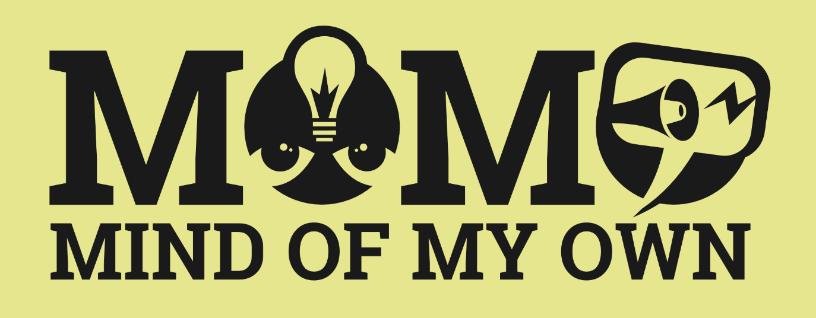
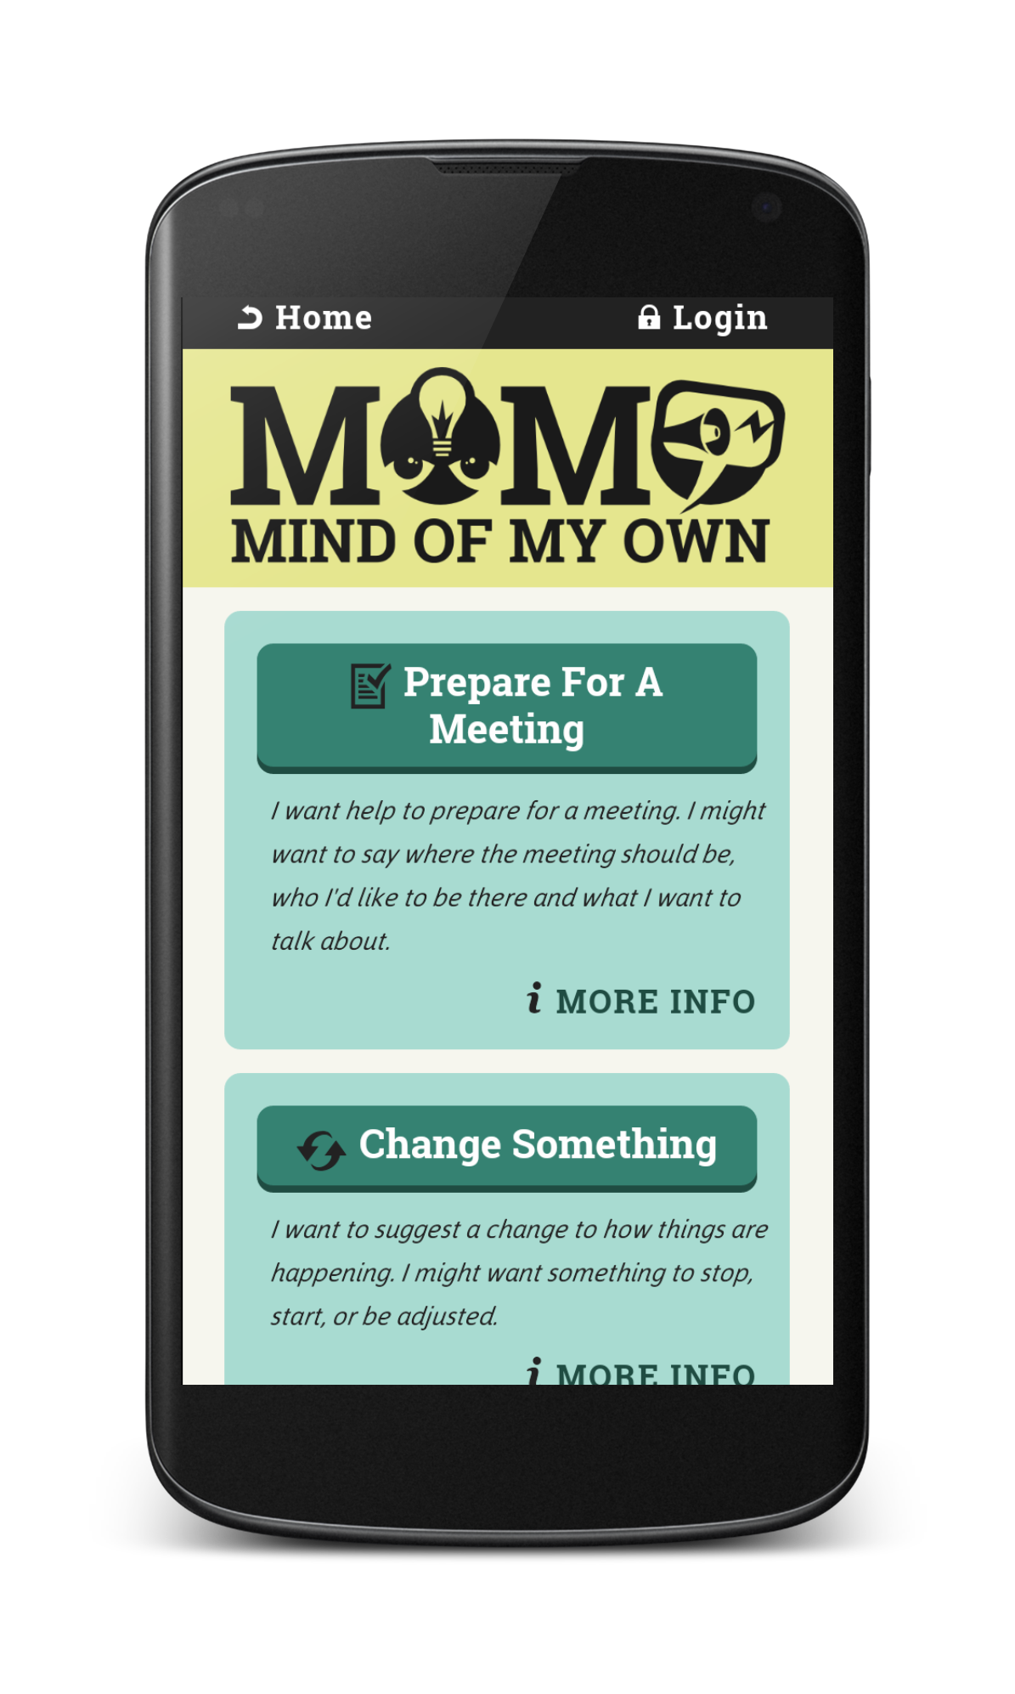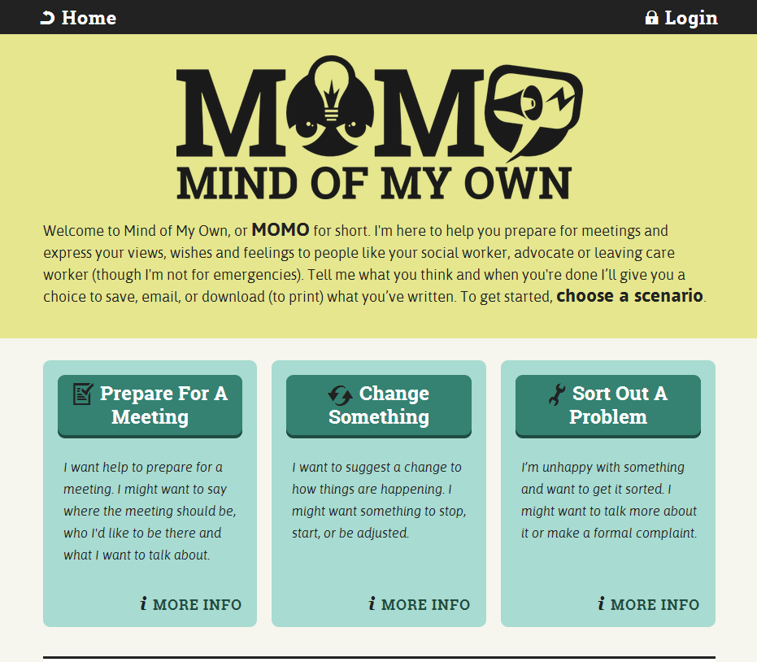
MOMO App Opening Screen
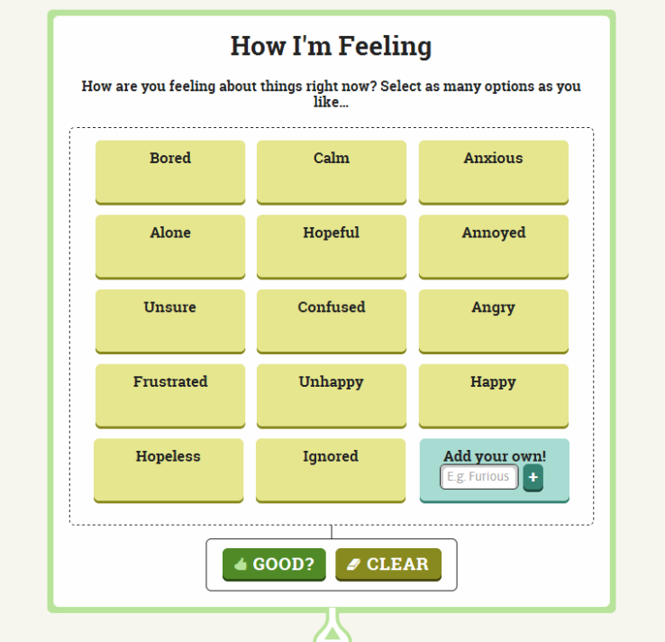
MOMO always starts by checking in with young people about how they are feeling
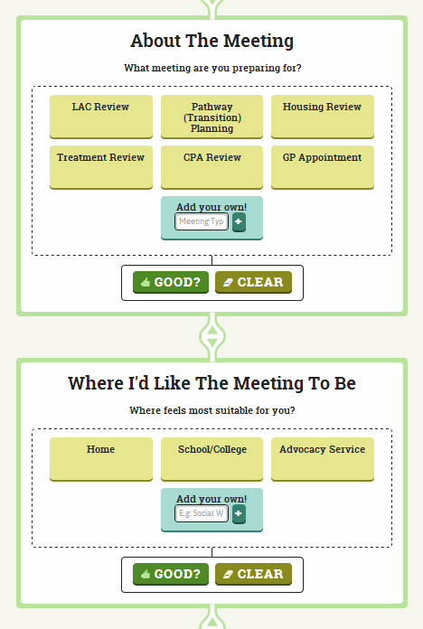
Prepare for a Meeting Scenario
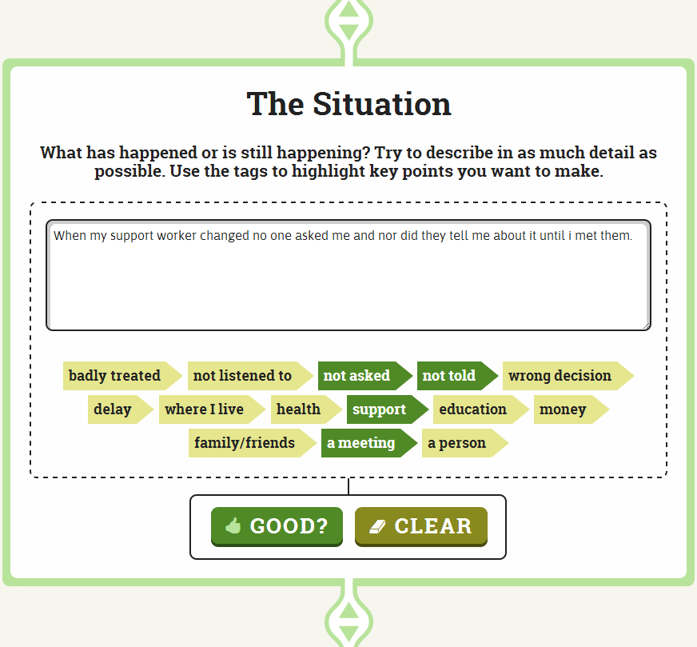
Get it Sorted Scenario

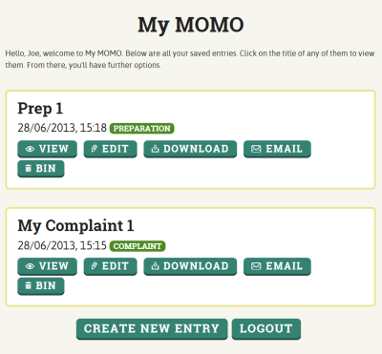
My MOMO - User Account Dashboard

Note: Roberto’s case study is a composite study, developed out of several young people’s experiences of using MOMO
Note: Annie’s case study is a composite study, developed out of several young people’s experiences of using MOMO

